- Data Import
- Download northwind-db.sql from classroom


- Open XAMPP and Click Explorer
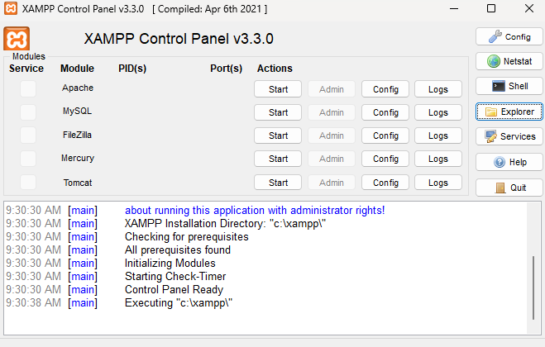

- Copy downloaded database to mysql folder.
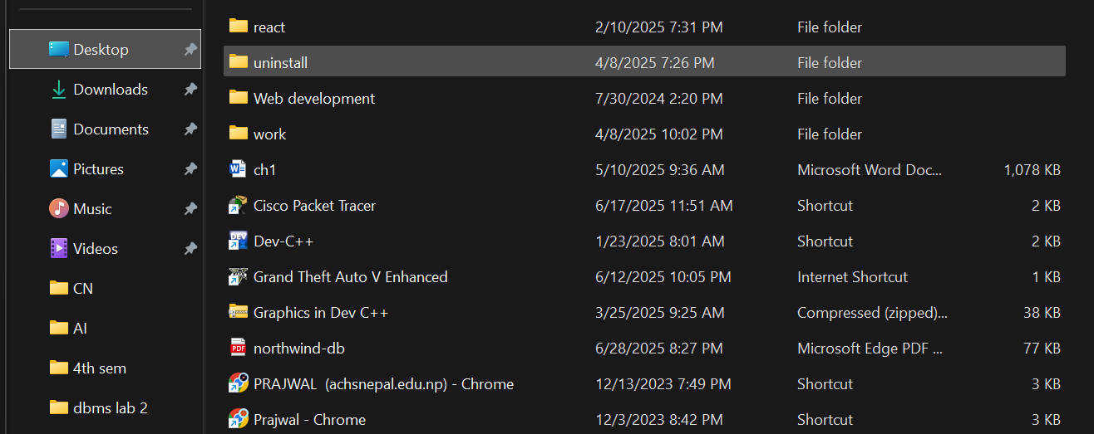

- Open Shell from XAMPP Admin Panel
Query:

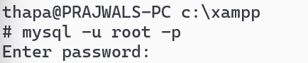

- Create database <yourname>northwind and exit
Query:

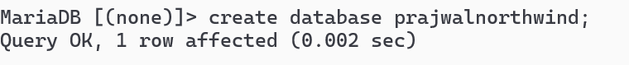

- Import database in <yourname>northwind using following command at SHELL
Query:

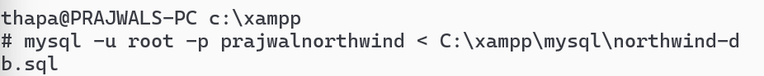

- connect to database using command mysql -u root -p
Query:


- Use <yourname>northwind database
- Use Prajwalnorthwind
Query:
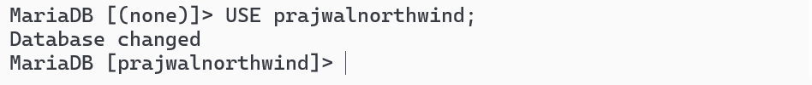

- Show tables
Query:

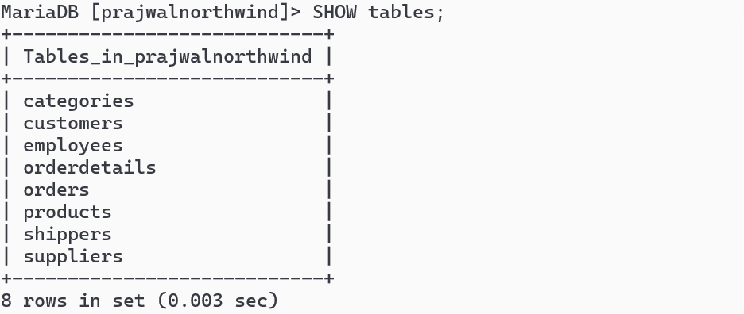

- Check attributes and constraints in each tables
Query:

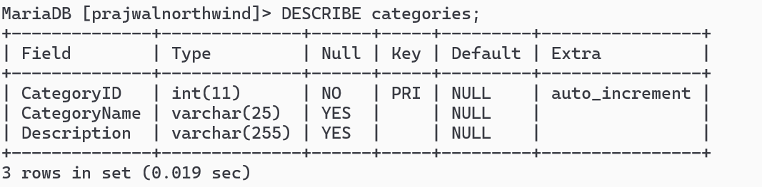Query:

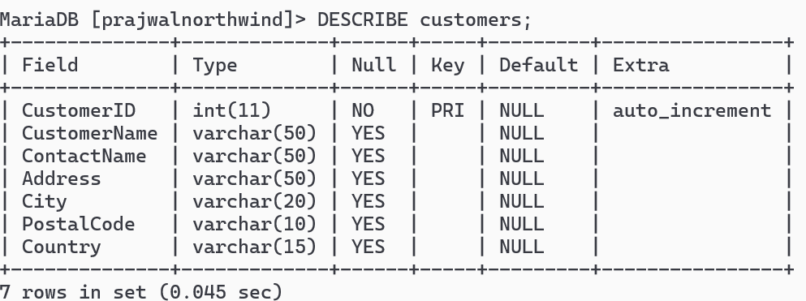

Query:
s
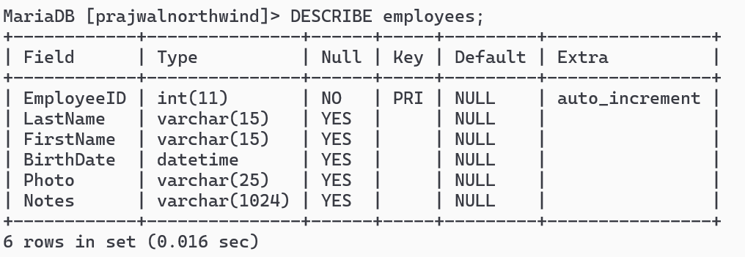

Query:

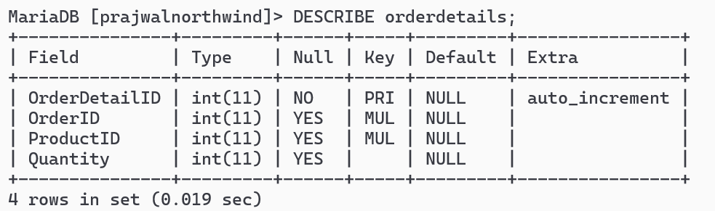

Query:

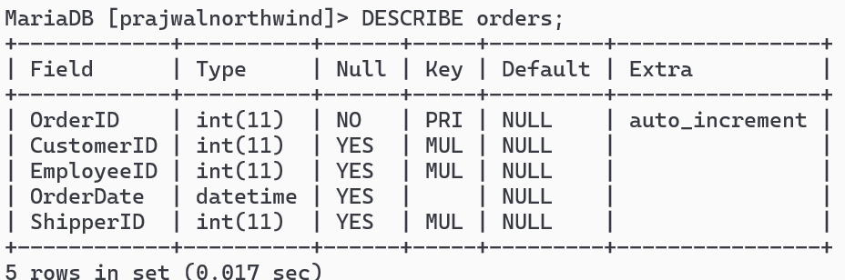

Query:

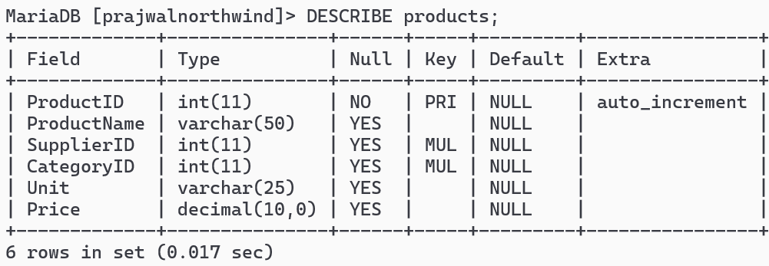

Query:

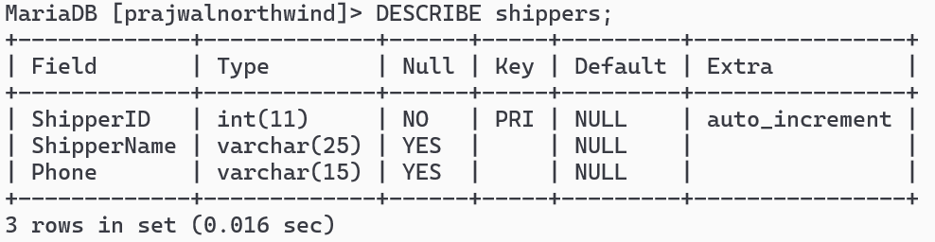

Query:

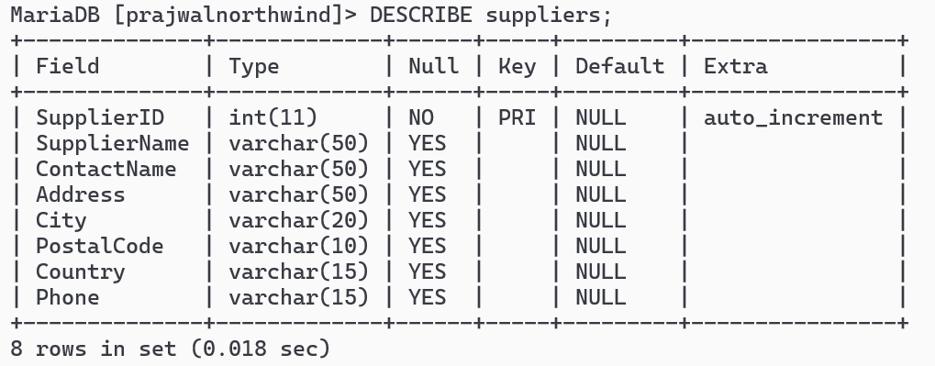

- Daw Entity Relationship Diagram
- Open https://draw.io


- Select appropriate storage for your draw.io files (Prefer: Google Drive)
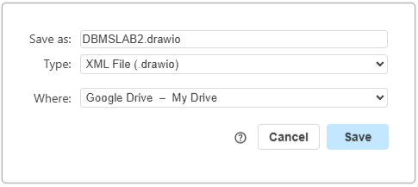

- Draw ER diagram of <yourname>northwind database

Query:

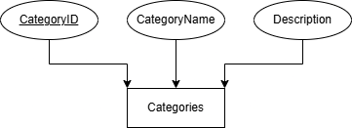

Query:

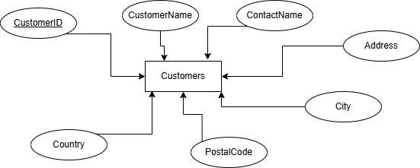

Query:

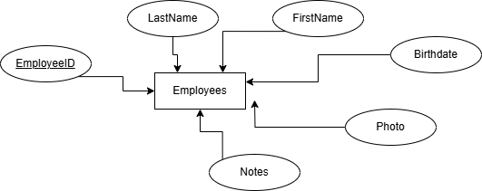

Query:

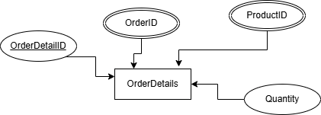

Query:

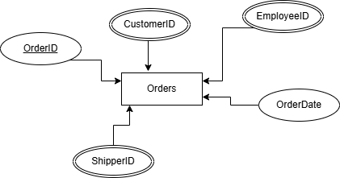

Query:

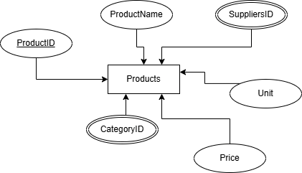

Query:

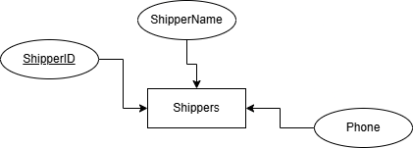

Query:

